The State of Residential Property Management and How Facility Management Can Help
From rising interest rates to continuous talk of a recession to falling resident satisfaction, trust, and confidence levels, there are many reasons why property management teams may have a cautious outlook.
The chart below shows the biggest risks that property management firms are concerned about during the next 12 months.
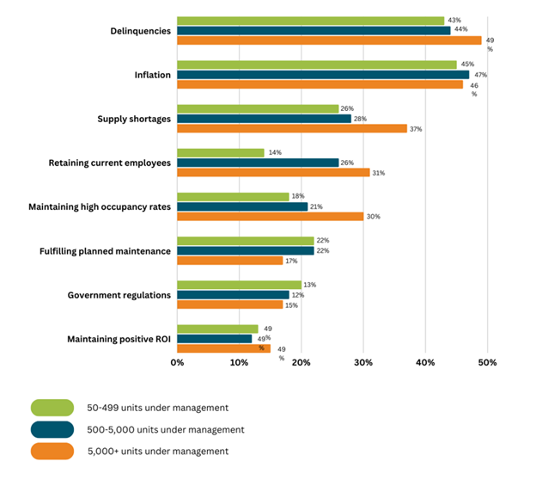
The residential property management sector's biggest concerns

Why Property Management Firms Need to Be Concerned About Maintaining High Occupancy Rates
While rents continue to increase steadily, resident satisfaction has been trending downward.
Though residents’ perception of the “value” of an apartment may be subjective, management companies can maximize their profits in the long term by better serving their residents in the short term.
To do so, multifamily property management companies need to understand how to balance rent growth with trust and loyalty from their residents, especially once market conditions take an inevitable turn.
Based on J Turner’s resident satisfaction metric – TALi (Turner Apartment Loyalty Index), resident satisfaction has decreased 13% since2019 and continues to descend due to inadequate cleanliness and security practices.
Most recently, in 2022, TALi was at 6.45, which can be attributed to frequent complaints by residents related to service and lack of adequate communication in online reviews.
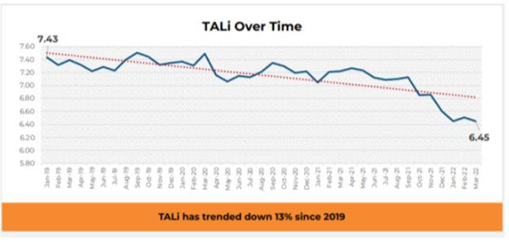
Chart courtesy of J Turner

The Tenant’s First Year is No Honeymoon
Currently, labor shortages are creating a gap between resident expectations and service received. Over an average lease, results indicate a “honeymoon phase” during the first three months, with satisfaction and trust typically declining by 15% in the first year, regardless of the renters’ fees.
Labor shortages on behalf of property managers and vendors in use are impacting customer service, maintenance service, living conditions, maintenance timeliness, move-in quality, and the condition of the overall community.
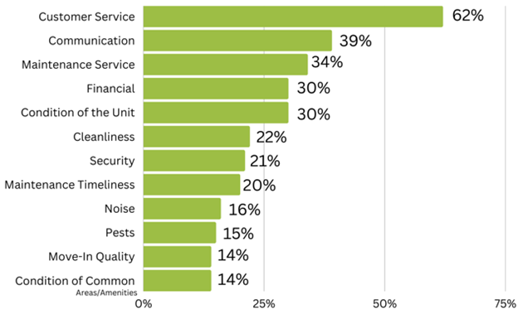
Top property management complaints in online reviews
Along with labor shortages, many property management firms cannot deliver consistent service to their tenants because they fail to consolidate facility management services.
Many residential property management firms take a traditional facility management approach. Each property will use a patchwork of providers with limited to zero oversight.
This leads to inconsistent performance and a longer time to resolve an issue. Therefore, leading to inconsistency in residents’ satisfaction, rental fees being charged to new vs. existing tenants, and fluctuating occupancy rates across every property in the portfolio.
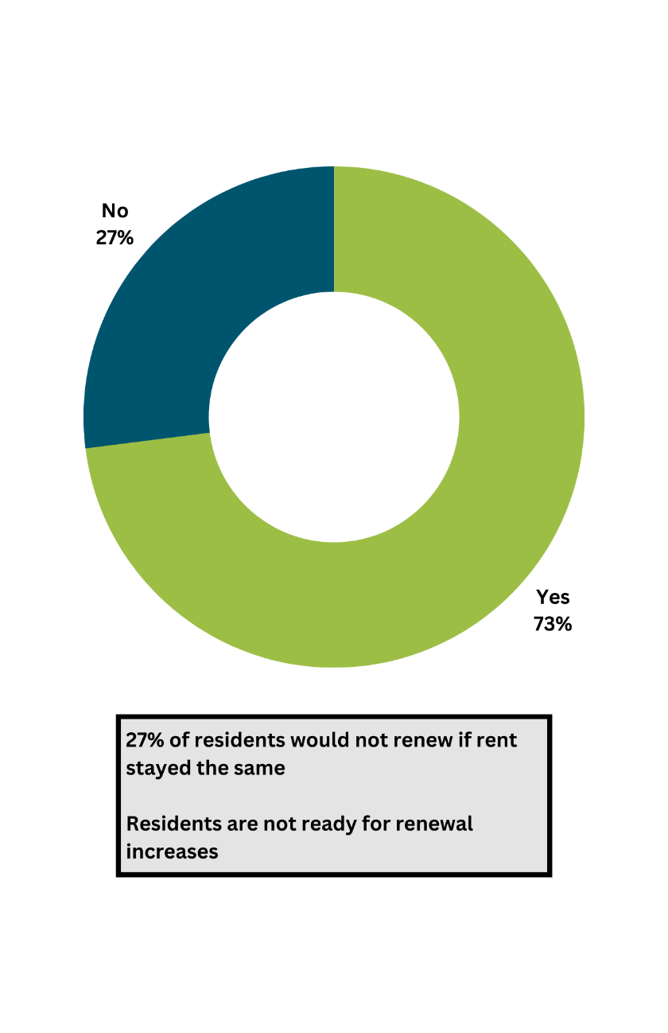
One of the challenges is that residential property managers view facility management services as a line-item cost versus using it as a competitive advantage to build resident satisfaction and trust.

How do you do that, though? Keep reading for insight into how to consolidate services to turn facility management into a competitive advantage!
What is Leading to Higher Resident Churn and Lower Occupancy Rates? (Hint, it might be alack of service!)
27% of residents would not renew if rent stayed the same. Notice the keywords there – “if rent stayed the same”.
This emphasizes the importance of resident satisfaction and building trust as “costs” are not a factor with this 27%. This number is even higher as rent increases do not seem to be slowing down anytime soon.

27% of residents would not renew even if rents stayed the same.

Focus on Increasing Resident Satisfaction Because Tenant Turnover is Costly
Recruiting new occupants involves spending money on marketing while losing money on a vacant unit.
In addition, when there is tenant turnover, you have the following:
- concession costs,
- leasing staff time costs,
- leasing commissions,
- carpet cleaning and other maintenance fees,
- appliance repair and replacement costs,
- painting costs
- other fees that quickly add up to more than $7500 per unit that is turned over.
The profit that property management companies lose during the turnover period could be avoided if there was a stronger focus on retention. More than 60% of customer turnover is controllable.
In 83% of cases where renters leave, it’s caused by a triggering event. This means that most tenant losses are avoidable. Property managers must remember that would-be and current tenants can go elsewhere for the same service. They must consider how their property can remain competitive in this marketplace.
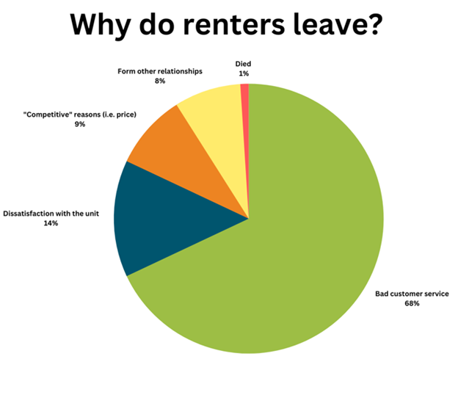
The vast majority of renters leave because of bad customer service.
By maintaining properties, responding to maintenance requests in a timely manner, and fostering tenant satisfaction, residents are encouraged to remain in the unit, giving management companies a steady cash flow and maximized profits.
To reach a tenant retention goal and maximize the lifetime value of a tenant, residents need to be satisfied with their current living situation. The goal of property managers should be 100% retention.
While they’ll always have tenants who must relocate because of jobs or life circumstances, there needs to be a greater focus on offering residents the best experience possible. This will result in the highest occupancy rate possible.
But property managers cannot offer residents the best experience when they look at facility management as a cost and compare SOWs (looking only at the activities) and then go with the lowest cost provider.
Property managers can only provide the best experience possible when they look at the impact (the output) a facility management provider can provide vs. the input. This is the only way property management firms will drive consistent rental fees, occupancy rates, and average tenant lifetime value across all locations.
It’s the only way property managers will reduce tenant churn and have a maximum impact on profitability.

Another Main Challenge: Managing Budgets and Operating Costs
Taxes and insurance make up the most significant expenses (32%of total expenses),followed by administration and payroll (26%), utilities (17%), and maintenance (12%), also account for significant chunks.
Keeping these expenses from overtaking the entire budget can be tricky for property management companies—especially when buildings age and need larger and more frequent repairs.
This is why many property management firms are now looking at streamlining and automating operations.
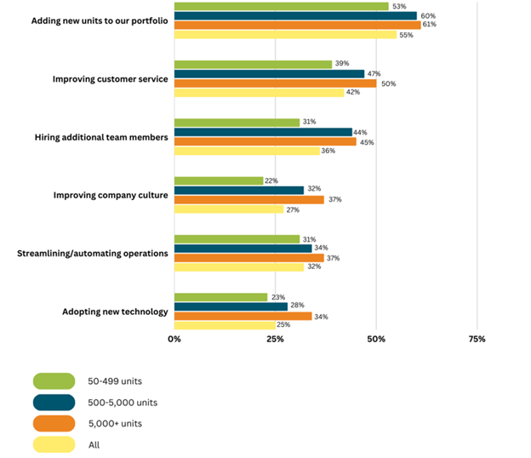
Methods property managers are using in an effort to streamline operations
Notice how improving the status quo is top of mind, particularly regarding customer service, as each group cited this as their second greatest opportunity.
Property managers are looking to become more efficient and aim to streamline and automate operations. This ranks as the third greatest opportunity for property management companies with 50-499 units under management (31%). It ranked as the fourth greatest opportunity for companies with 500-5,000 units under management(34%) and companies with over 5,000 units (37%).
Property management companies want to streamline and automate operations to reduce costs, as managing multiple vendors impacts margins.
They want to improve project management processes to improve customer service and response times of maintenance requests. In addition, they want to improve account-payable processes to control spiraling costs and gain administrative efficiencies.
Property managers also want to free up their team from labor-intensive processes that take the attention away from providing residents with the experience they want and deserve.
However, this can only be achieved by consolidating facility management services with a provider that delivers complete visibility at the site, regional and national levels.
This is important as many property managers see visualization of tasks as a big opportunity for improvement. Management of day-to-day tasks and needs is another point of contention. The big question is: How do you visualize what needs to be done so that everyone can see the big picture and the underlying tasks?
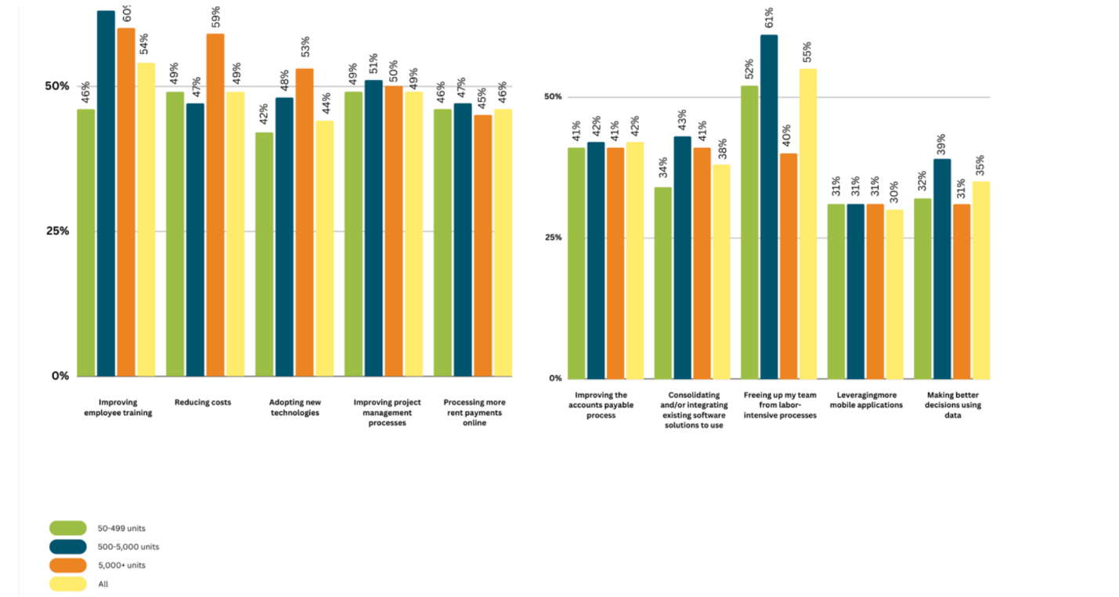
Visualizing what needs to be done to improve

Aggregated Facility Management Services Are Adding Risk
As property management firms look to streamline and automate operations, many are turning to aggregators that partner with local and regional supplier networks to try to pull people together through technology.
But this approach impedes a more unified category solution. In the aggregator business model, the aggregator firm collects information about providers, signs contracts with these providers, and sells their services under its brand to property management firms.
When in-sourcing or using an aggregator, there will always be some absent resource, and when additional cleaning is required, there are often insufficient resources available, impacting resident satisfaction and trust.
One specific challenge for property managers in working with aggregators is ensuring service consistency. You don't know who will show up, and it could be a different person each time, adding risk.
Property managers require a provider specifically catering to the property management sector. This type of property will focus and be aligned with the company, compliance regulations at the local, state, and national levels, and the individual needs and wants of the tenants.
Although property managers may enjoy standardized best practices, they should be looking for services that are tailored to the needs of each individual community.
At OpenWorks, we are known for and pride ourselves on treating each site as its own. We don’t believe that that standard is good enough for our clients. That’s why we go further than necessary so each of your sites in your portfolio is treated exactly to its needs.

Fixing the State of Facility Management in Property Management Starts with a Shift in Mindset
Property management firms can win back trust, see higher occupancy rates and rental fees across all regions and protect their P&L.
But they need to change how they look at facility management. Rather than being a line item cost that property managers at the site level take care of, facility management should be seen as a regional and national corporate initiative to improve the resident experience in a way that positively impacts profitability.
Are you looking to impact your residential profitability and improve the level of service at your residential property? Contact us! We’ll be your partner to ensure your tenants stay satisfied for the length of their leases (and maybe they’ll stay a little longer).

