**Meta Description:** Preventative facility maintenance is key to achieving zero-emission goals by optimizing energy use and reducing carbon footprint. Learn how proactive and predictive maintenance strategies foster sustainability and efficiency while reducing operational costs.

**Social Copy**: Learn why proactive facility maintenance is essential for reaching zero-emission goals.

**Alt Image Copy**: A maintenance technician in a high-visibility vest and hard hat working on a laptop computer within an industrial environment, with various tools and equipment in the background.

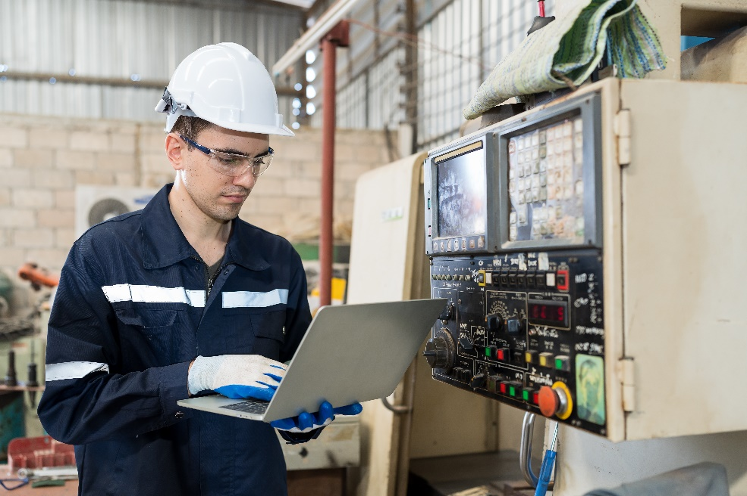

https://www.shutterstock.com/image-photo/male-engineer-worker-working-laptop-computer-2229259763

# How Preventative Facility Maintenance Can Drive Your Zero Emissions Goals

Reducing carbon emissions is a top priority for businesses aiming for sustainability. One of the most effective ways to achieve a zero-emission goal is through preventative facility maintenance. Facilities consume large amounts of energy and without proper maintenance, inefficiencies can result in unnecessary waste and increased emissions. By implementing a proactive maintenance strategy, businesses can optimize energy use, reduce their carbon footprint and promote long-term sustainability.

## What Is Preventative Facility Maintenance and Why Does It Matter?

Preventative facility maintenance is a proactive strategy involving routine inspections, regular servicing and necessary repairs to prevent equipment failures. It differs from reactive maintenance, which only responds after breakdowns, and predictive maintenance, which uses data analytics to forecast issues. This scheduled approach ensures optimal functionality by checking performance, replacing worn parts and verifying safe operations. Early problem identification reduces operational disruptions, energy waste and costs, while enhancing overall equipment efficiency. Implementing a strong [preventative maintenance program](https://www.aerotek.com/en/solutions/services/preventative-maintenance-services) fosters a safer work environment and extends the lifespan of critical assets.

## The Connection Between Facility Maintenance and Zero Emissions Goals

A well-maintained facility is essential for reducing emissions across various categories. Scope 1 emissions, which originate from direct sources like fuel combustion, can be minimized by ensuring that HVAC systems, boilers and generators operate efficiently. Similarly, Scope 2 emissions — resulting from purchased electricity — decrease when lighting, heating and cooling systems function optimally. Even Scope 3 emissions, which include indirect environmental impacts such as those from supply chain operations, can be lessened through sustainable maintenance practices.

[Facilities account for nearly 40% of global energy consumption](https://www.sciencedirect.com/science/article/abs/pii/S1364032114010053#:~:text=Introduction,1%5D%2C%20%5B2%5D.), making maintenance a critical factor in lowering overall emissions. Poorly maintained equipment tends to consume excessive energy, leading to higher emissions and increased operational costs. Real-world examples demonstrate that businesses implementing [preventative maintenance](https://www.aerotek.com/en/insights/these-preventive-maintenance-best-practices-could-kill-your-efforts) strategies have significantly reduced their carbon footprint..

### The Role of Predictive Maintenance in Zero Emissions Goals

Predictive maintenance, enhanced by the integration of IoT sensors and AI-driven monitoring technologies, revolutionizes the approach to equipment care by identifying potential failures before they arise. Unlike traditional preventative [maintenance](https://www.aerotek.com/en/solutions/services/comprehensive-maintenance-services), which often relies on fixed schedules, predictive maintenance utilizes advanced algorithms and real-time data analytics to continuously assess equipment performance. This allows for the early detection of inefficiencies and the timely scheduling of repairs, thereby preventing minor issues from escalating into significant, costly breakdowns.

The benefits of adopting predictive maintenance practices are multifaceted. One of the primary advantages is the significant reduction in equipment downtime, which can lead to increased productivity and reduced operational costs. By anticipating problems, organizations can perform maintenance during non-peak hours, minimizing disruptions to operations. Furthermore, predictive maintenance contributes to increased energy efficiency. When equipment operates optimally, energy consumption decreases, which not only saves costs but also contributes to a reduced carbon footprint.

In addition to operational benefits, predictive maintenance also supports improved compliance with environmental regulations. As industries face increasing scrutiny regarding their environmental impact, maintaining efficient equipment helps ensure adherence to these regulations by reducing unnecessary emissions. By leveraging smart maintenance technologies, businesses can take a proactive stance in addressing potential issues and enhancing their overall sustainability. This holistic approach to maintenance not only fosters operational efficiency but also aligns with broader corporate responsibility goals, ultimately positioning organizations for long-term success in an evolving market.

## Optimizing Preventative Facility Maintenance for Zero Emissions Success

A targeted preventative maintenance strategy can greatly enhance sustainability efforts. Key areas to focus on include HVAC systems, lighting, building envelope integrity and water efficiency.

### Energy-Efficient HVAC Systems

[According to the International Journal of Environmental Research and Public Health](https://pmc.ncbi.nlm.nih.gov/articles/PMC8776175/), HVAC systems are one of the largest contributors to a facility’s energy consumption, accounting for nearly 50% of total energy use. Regular maintenance — such as cleaning or replacing air filters, sealing ducts and monitoring refrigerant levels — ensures that these systems operate efficiently. Upgrading to smart thermostats and energy-efficient units can also help reduce energy waste. Additionally, detecting and repairing air leaks in ventilation systems prevents unnecessary strain on HVAC units, optimizing their performance and reducing emissions.

### Sustainable Lighting Upgrades and Routine Inspections

Lighting constitutes a substantial part of a facility's electricity consumption. Transitioning to LED lighting, which uses 75% less energy than traditional bulbs, is a straightforward yet impactful step toward sustainability. Regular inspections to clean fixtures and replace faulty components help maintain efficiency. Additionally, smart lighting controls, such as motion sensors and daylight harvesting systems, further optimize energy use by ensuring that lights are on only when necessary.

### Building Envelope Maintenance

The building envelope, which consists of walls, roofs, windows and doors, is essential for energy conservation. Inadequate insulation and air leaks can lead to significant energy loss, causing HVAC systems to work harder than necessary. Conducting regular inspections and maintaining weather stripping, insulation and roofing materials can help maintain indoor temperatures and reduce overall energy consumption. A well-maintained building envelope not only reduces emissions but also improves occupant comfort and lowers utility costs.

### Water Efficiency and Plumbing System Maintenance

Water waste contributes to energy overuse and higher emissions, particularly in large facilities. Leaky pipes and inefficient fixtures lead to unnecessary water consumption and increased demand for heating water, which requires energy. Implementing water-efficient appliances, low-flow fixtures and routine plumbing inspections can significantly reduce waste. Additionally, integrating greywater and rainwater harvesting systems into facility maintenance plans supports long-term sustainability efforts.

## Leveraging Preventative Maintenance for ESG Compliance and Regulatory Goals

Preventative maintenance is vital not only for energy savings but also as a key element of corporate ESG (Environmental, Social, Governance) strategies. Many businesses are required to adhere to sustainability standards such as LEED (Leadership in Energy and Environmental Design), ENERGY STAR certification and ISO 50001 for energy management. Keeping thorough records of maintenance activities and sustainability initiatives is essential for compliance with these standards and showcases a company's commitment to environmental responsibility. Organizations that actively maintain their facilities are better equipped to meet regulatory requirements and attract environmentally conscious stakeholders.

## FAQs

**How does facility maintenance reduce carbon emissions?**

Regular maintenance ensures that equipment operates efficiently, which helps prevent unnecessary energy waste and minimizes emissions. By optimizing systems such as HVAC, lighting, plumbing and building insulation, facilities can significantly decrease their carbon footprint.

**Which industries benefit the most from preventative maintenance in terms of emissions reduction?**

Industries with large-scale facilities — such as manufacturing, commercial real estate, healthcare and logistics — experience the most significant benefits. These sectors rely on energy-intensive systems, making effective maintenance crucial for sustainability.

**How much can businesses save by implementing a preventative maintenance program?**

Research indicates that businesses can reduce energy costs by engaging in regular maintenance and implementing efficiency upgrades. Investing in preventative maintenance not only leads to long-term savings but also supports goals for zero emissions.

Prioritizing preventative facility maintenance is crucial for businesses aiming to enhance sustainability and improve operational efficiency. By adopting effective maintenance strategies, organizations can significantly reduce their environmental impact and work toward achieving zero-emission goals. This proactive approach not only supports environmental objectives but also leads to substantial cost savings over time. Ultimately, implementing these practices can result in a win-win situation where companies advance their sustainability initiatives while also benefiting financially.