Lights, Camera, Action – How to Keep Your Movie Theater Sparkling
Written by OpenWorks
In the world of entertainment, movie theaters hold a special place. They offer an escape from reality, a chance to be transported to different worlds, and a communal experience that can't be replicated at home.
As a facility manager, you take on nearly as many roles as the actors on the silver screen! From overseeing cleaning crews to managing multiple rooms of video technology to dealing with food service and keeping everyone calm in crisis situations, you are the real star when it comes to keeping the show running.
Discover tips and tricks you can use as a movie theater facility manager in this unique environment to excel in your role.

Understanding the Movie Theater Environment

Competition brought on by streaming services has affected the move theater-going experience.
Before diving into the specifics of managing a movie theater, it's essential to grasp the unique challenges posed by this venue. Plus, it's been proven that cleanliness is the main key that can keep you ahead of competition in the entertainment arena. Here's a look at what you should be aware of:
- High Foot Traffic and Continuous Operation: Movie theaters operate daily and often for extended hours. This means there's a constant influx of visitors, resulting in a higher cleaning demand.
‍
- Varied Audience Demographics: Moviegoers can range from families with children to teenagers and adults. Each group has distinct needs and behaviors, which must be considered when planning cleaning routines.
‍
- Food Service Areas with Potential Spillage: The presence of food and beverages in movie theaters increases the risk of spills and messes. Proper maintenance and cleaning are crucial to ensure a clean and safe environment for everyone.

The Essential Responsibilities of Facility Managers

As a move theater facility manager, you have the responsibility to keep entire families safe.
As a facility manager, your role encompasses a wide range of responsibilities to maintain a clean and safe environment for not just moviegoers, but your entire staff.
Here are the core duties you should prioritize:
- Establishing a Comprehensive Cleaning Schedule: Develop a detailed cleaning schedule that covers all areas of the movie theater, including auditoriums (especially in between those popcorn-packed seats), restrooms, lobbies, and food service areas. Ensure this schedule aligns with movie showtimes to minimize disruption.
‍
- Implementing Rigorous Safety Protocols: Safety should always be your top priority. Train your cleaning crew on safety procedures and provide them with the necessary protective equipment. Regularly inspect the facility for potential hazards and address them promptly.
‍
- Scheduled Maintenance Checks: Preventive maintenance is key to avoiding unexpected issues or canceled showtimes. Schedule routine checks of HVAC systems, lighting, electrical, and plumbing to identify and address problems before they escalate.

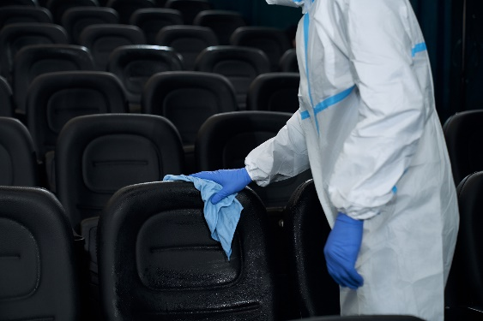

Effective Strategies for Managing Your Cleaning Crew

Cleaning, not just picking up popcorn, is absolutely essential.
Once you have the basics down, here are some tips and tricks to manage your movie theater’s janitorial staff:
- Team Coordination and Communication: Maintain open lines of communication with your cleaning crew. Regularly meet to discuss priorities, address concerns, and ensure everyone is on the same page.
‍
- Training and Skill Development: Invest in training programs for your cleaning crew. This includes teaching them how to use cleaning equipment efficiently, handle cleaning chemicals safely, and address different types of spills effectively.
‍
- Utilize Cleaning Technology: Explore cleaning technologies and equipment that can enhance your crew's efficiency. This includes robotic cleaners, advanced cleaning chemicals, and digital scheduling tools.
‍
- Delegate and Empower: Assign specific roles and responsibilities to different members of your cleaning crew based on their strengths and expertise. Empower them to take ownership of their tasks, which can lead to increased job satisfaction and better results.

Your Checklist for Success in Managing a Movie Theater Facility
Develop a comprehensive cleaning schedule that aligns with movie showtimes:
- Identify Peak Hours: Analyze movie showtime patterns to identify peak hours when the theater experiences the highest foot traffic.
‍
- Create a Customized Schedule: Design a cleaning schedule that revolves around peak and off-peak hours, ensuring that high-traffic areas are cleaned during downtime.
‍
- Assign Responsibilities: Clearly define cleaning tasks and assign them to specific crew members to ensure efficient coverage.
‍
- Regular Updates: Continuously update the schedule to adapt to changing movie release patterns or special events.

Invest in training and development programs for your cleaning crew to ensure efficiency and expertise:
- Assess Training Needs: Evaluate the skills and knowledge gaps within your cleaning crew to tailor training programs accordingly.
‍
- Provide Ongoing Training: Offer regular training sessions on cleaning techniques, safety protocols, and the proper use of cleaning equipment.
- Certification: Encourage crew members to pursue relevant certifications to stay up-to-date with the latest cleaning trends.
‍
- Performance Monitoring: Implement a system for monitoring and assessing the performance of your cleaning crew, providing constructive feedback for improvement.

Embrace modern cleaning technologies and equipment to streamline operations:
- Technology Assessment: Research and identify cleaning technologies and equipment that are suitable for your theater's specific needs.
‍
- Invest Wisely: Allocate budget for acquiring and maintaining modern cleaning equipment, including high-efficiency vacuum cleaners, floor scrubbers, and sanitization systems.
‍
- Training on Equipment: Ensure that your cleaning crew is well-trained in using these technologies to maximize their efficiency.
‍
- Regular Maintenance: Establish a maintenance schedule for equipment to prevent breakdowns and ensure they remain in optimal working condition.

Maintain open communication and delegate responsibilities to empower your cleaning crew:
Keeping cleaning staff updated and in the know, is key.
- Regular Meetings: Schedule regular meetings with your cleaning crew to discuss challenges, improvements, and feedback.
‍
- Feedback Loop: Create a feedback loop where crew members can voice their suggestions or concerns about cleaning processes.
‍
- Delegate Authority: Empower experienced crew members by delegating supervisory roles to oversee specific areas or shifts.
‍
- Recognition and Rewards: Recognize and reward outstanding performance to motivate and encourage a sense of ownership among your cleaning crew.
‍
By implementing these action steps, you can establish a well-organized and efficient cleaning system for your movie theater, ensuring a clean and enjoyable experience for your patrons while optimizing operational efficiency.
Ready to shine in your role as a facility manager and ensure a "reel-y" good movie going experience for your patrons? OpenWorks is here to provide support and operational oversight for your buildings while making your facilities safer, cleaner and more compliant. It's a team effort and all of us at OpenWorks are focused on you! Click here to learn more about OpenWorks’ facilities management services.

