Title: Loma Linda University Health Continues to Innovate by Connecting Location to Better Patient Outcomes

Loma Linda University Health (LLUH) is recognized as one of the top academic medical centers in Southern California. Its operations include six hospitals, a physician practice corporation, remote clinics in the western United States, and affiliates around the globe. The center is known and respected for advanced technology, service-oriented medical care, and education. It is recognized worldwide for its revolutionary efforts including the first proton unit used for cancer treatments and the first infant heart transplant. The Loma Linda University School of Public Health also pioneered health geographic information system (GIS) research, successfully leveraging location for improved health outcomes. LLUH's focus on location intelligence is now spreading to the operations of its facilities.
Challenge
Treating more than 1.5 million outpatients every year prompts LLUH to continue to look for ways of improving patient care through a digitally driven insight. The hospitals and ambulatory clinics rely on Epic's electronic health records (EHR) system to manage their patient data. In a parallel system of record, they rely on Esri's ArcGIS to maintain, manage, and analyze their location data, which enables patients to easily navigate to the correct buildings, parking lots, and offices for their appointments. After some careful thought as to how best to bring about a more wholistic view of their patients, management staff recognized the potential of gaining new insights by integrating these two systems. They realized that leveraging this valuable location data would transform their operations and, in turn, improve patient experience.
Solution
Critical to Epic's functionality is their Admission, Discharge, Transfer (ADT) module, which houses the location and status of every patient. The medical staff were tracking all this critical information, but they had no way to visualize and analyze it. Combining the Epic EHR data with the patient location data in the Esri GIS quickly transformed the information into actionable information, such as rapidly identifying hot spots and emerging trends and improving coordination of work across departments. 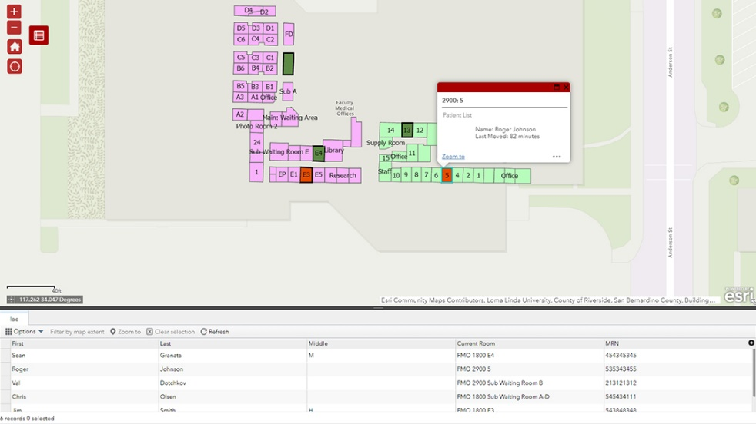
Caption: Combining Epic EHR data with Esri’s ArcGIS allows LLUH providers to spatially assess critical patient data.
By integrating their two existing enterprise systems, Epic and Esri's ArcGIS, LLUH staff can now quickly and easily see the locations of their patients. By connecting the ADT feed with ArcGIS, staff can now quickly improve decision-making through a real-time operations dashboard of the status of their patients. The new workflow doesn't require any additional time or effort for staff. They simply enter the patient data as they have in the past; the only difference is that the data is now being displayed visually. They can now easily see what's happening with their patient load in real time, identify long wait times or trouble spots, and respond accordingly.
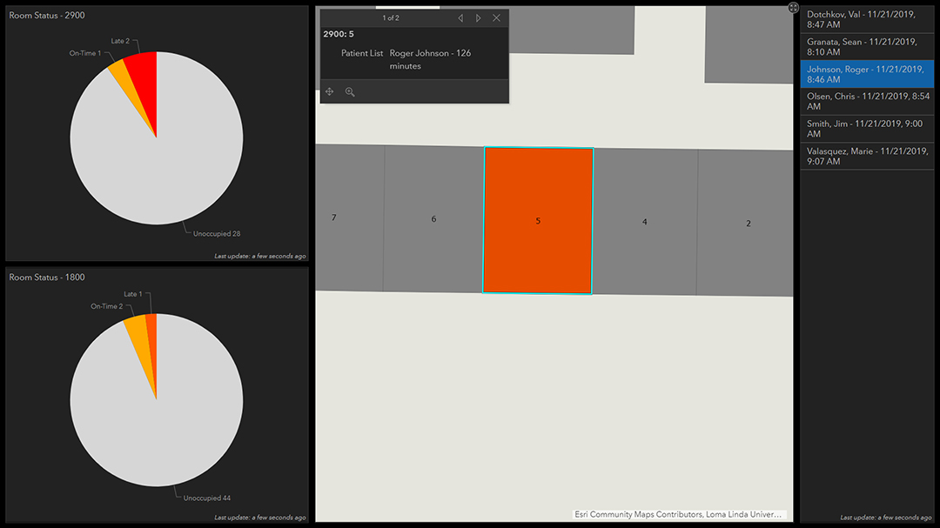
Caption: By connecting the Epic data feed with ArcGIS, LLUH providers now have a complete real-time view of their patient flow, enabling them to identify increased wait times and respond accordingly.
Results
The immediate value is getting a comprehensive view of the patient flow through the clinic. Over time, they are going to analyze the data to identify trends and patterns, which can then be used to make better decisions and improve the patient experience. As Bert Chancellor, the executive director of information services at Loma Linda University Health, explains, "The real value is not just visualizing something; everyone can do that. The real value is to have the knowledge and ability to be impactful over a period of time."
With strong support from leadership, LLUH is planning to roll out this integration to additional clinics in the future. As Chancellor explains, "Integrating enterprise platforms is transformative. Enhancing electronic health records with location analytics improves the patient experience, resulting in data-driven decision-making, and provides extra insight into data."
“Integrating enterprise platforms is transformative. Enhancing electronic health records with location analytics improves the patient experience, resulting in data-driven decision-making, and provides extra insight into data.”
Bert Chancellor, Executive Director of Information Services, Loma Linda University Health

